PRESS RELEASE

Martinez Historical Society
PO Box 14 (1005 Escobar Street)
Martinez, California

Date: September 21, 2016

Contacts: Carolyn Boone Duncan
Email: cfboone@aol.com
Telephone: (925) 864-8457

John Curtis
Email: CurtisJD@ix.netcom.com
Telephone: (925) 957-1000

The Historic Home Tour in Martinez

Returns on Saturday Oct. 8th

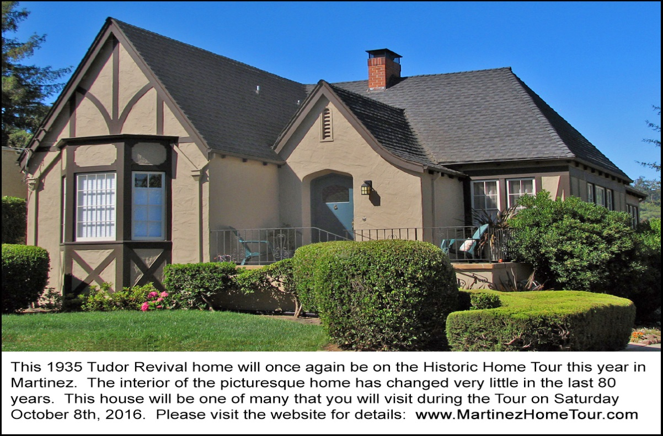
This 1935 Tudor Revival home will be one of seven houses on the 2016 Historic Home Tour in Martinez.
The owner of this house has been very diligent in preserving the home just as it was built 81 years ago.

MARTINEZ. The Martinez Historical Society will host its 10th annual Historic Home Tour on Saturday, October 8th. The Tour will enable you to walk through 7 very interesting private homes – an opportunity that you may never have again.

There will also be a wildlife garden on the tour this year in which rescued animals reside until rehabilitated. In addition, the Tour will include a public building: the Martinez Junior High School, a 1931 Spanish Revival building that won a statewide award for its design. You'll also have the option of seeing the new exhibits in the just-renovated Martinez Museum before it reopens to the general public a week later.
The Tour will begin at the Shell Clubhouse. Complementary coffee will be served. There will be interesting displays to be seen, and the Shell Museum next door will be open. If you don’t wish to drive the Tour, buses will leave the Clubhouse every 10 minutes. There will be tour guides on each bus. And docents will be stationed in each home to point out the features of each house. You'll encounter local musicians along the way. Allow 2 or more hours for the Tour.
Photos and more information about the Tour are on the website: www.MartinezHomeTour.com
Home Tour tickets are $25 in advance or $30 at the door. Tickets can be purchased by credit card at www.martinezhometour.com. You can also purchase tickets with checks or cash from the four Martinez merchants listed on the website.
The Historical Society thanks the following sponsors who make this tour possible:
Shell Martinez Refinery, Cole Real Estate, West Berkeley Design Loop, Shell Chemical Company, Republic Services, Shell Western States Federal Credit Union, Hagin’s Automotive, Bisio/Dunivan, Les Schwab Tire Center of Martinez, Ecomulch, Community Focus, City of Martinez, Leading Edge Pest Management, Schroder Insurance, Connolly & Taylor Chapel and Michael Briones of J. Rockcliff Realtors.
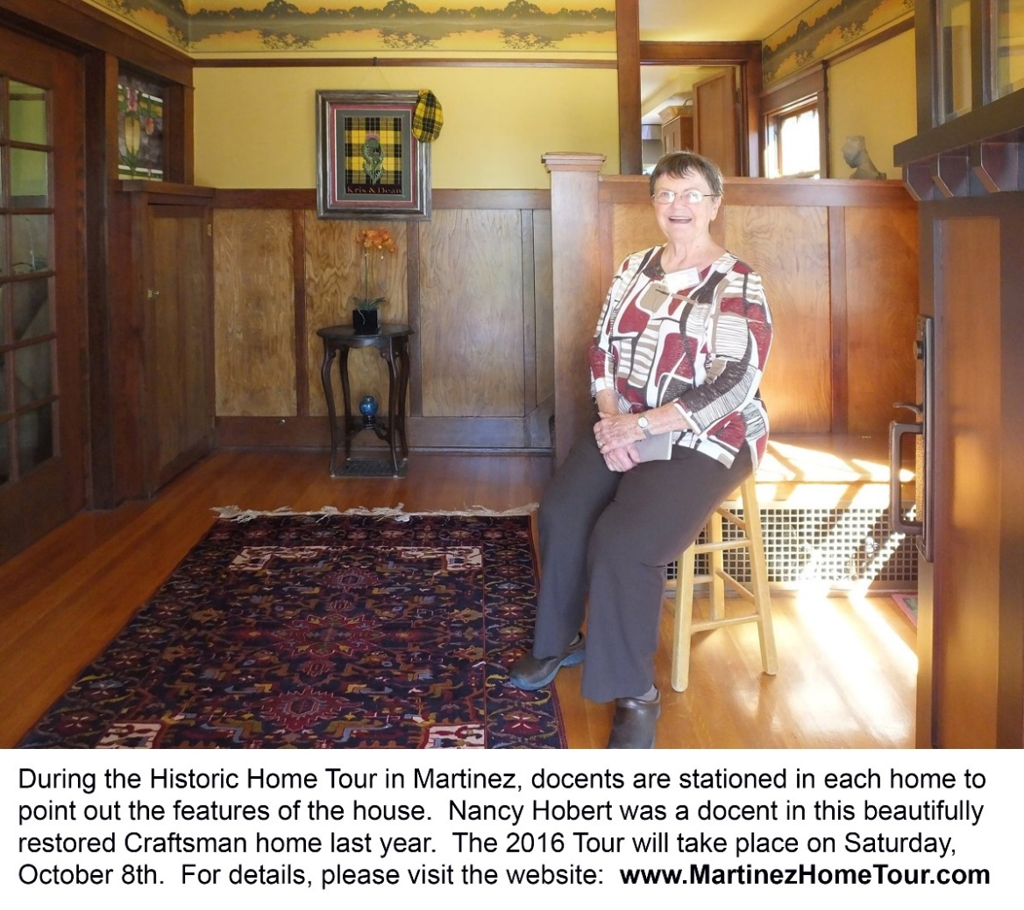

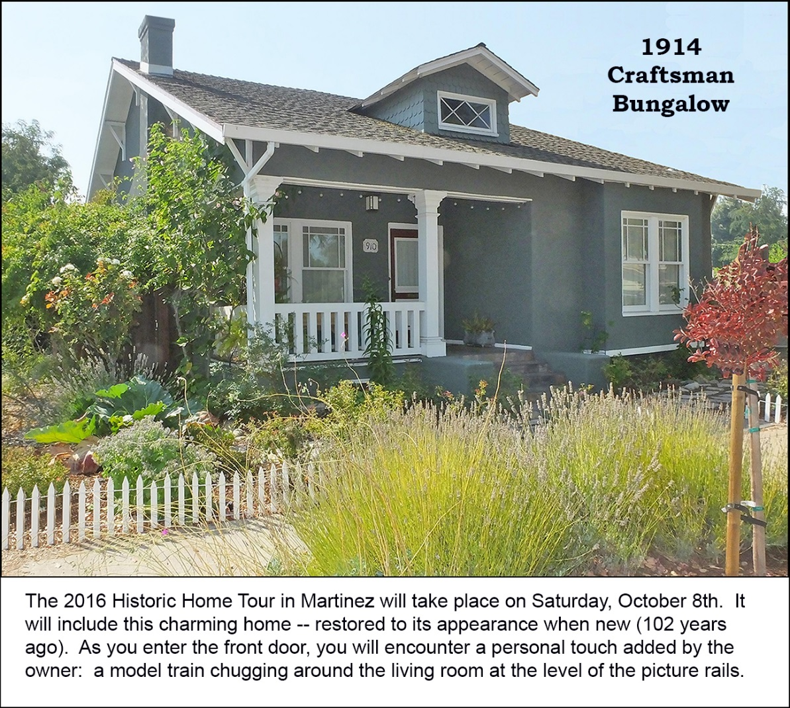

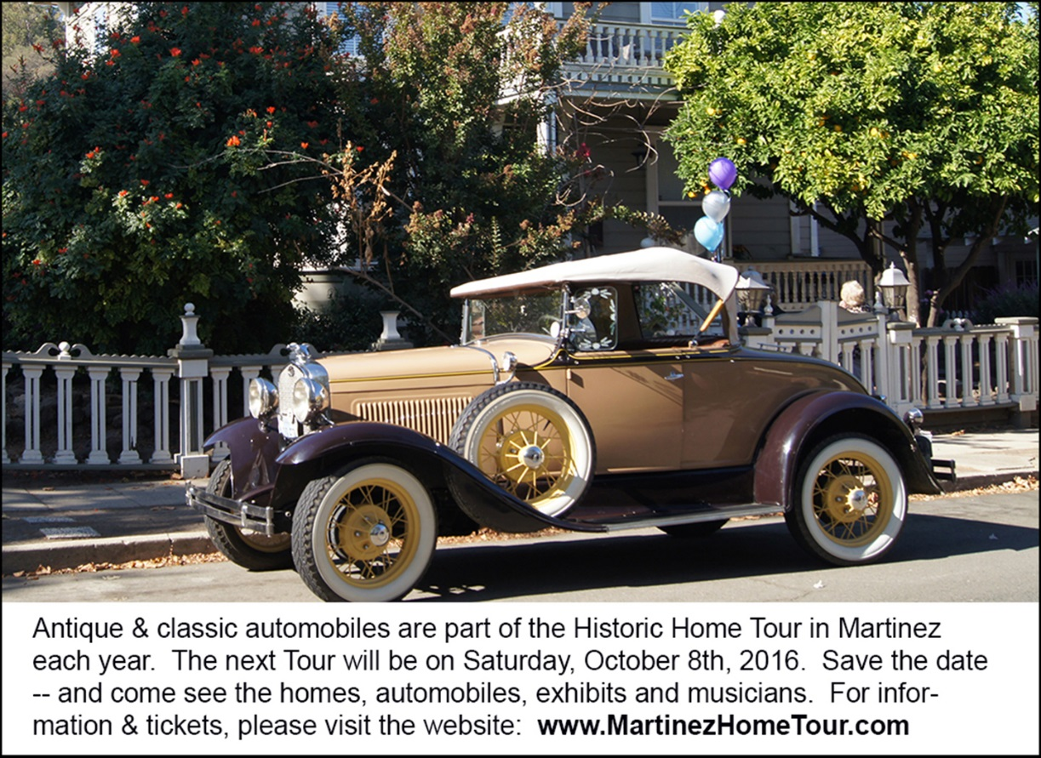

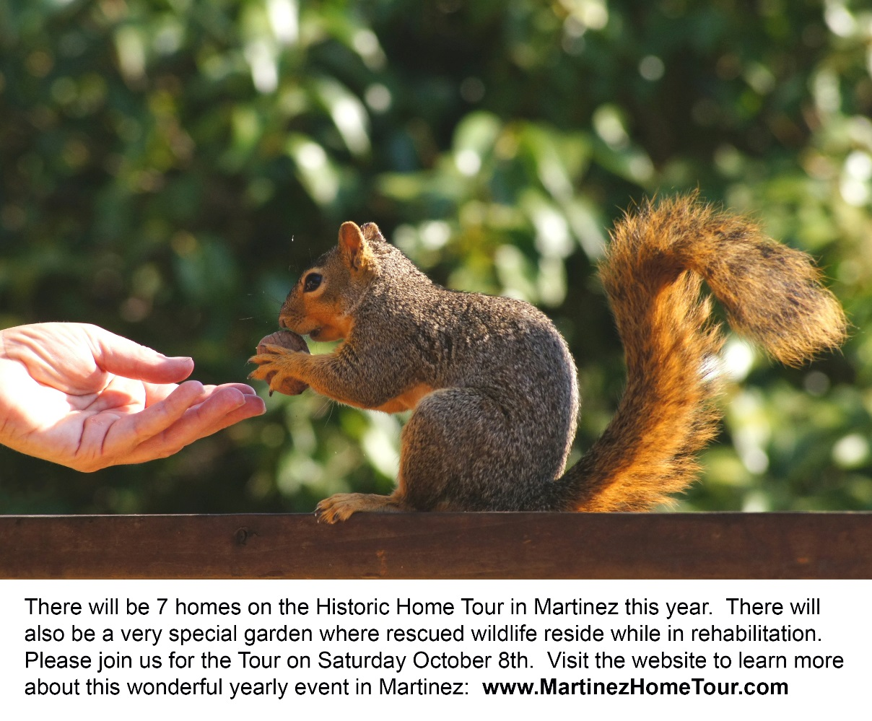

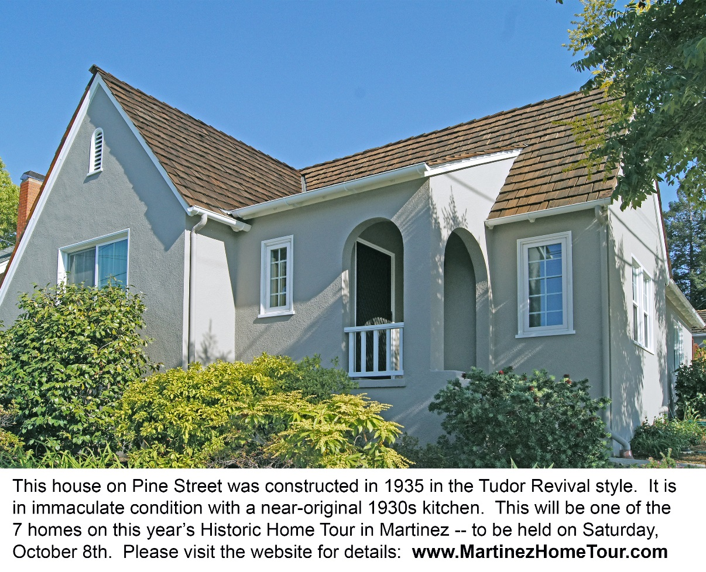

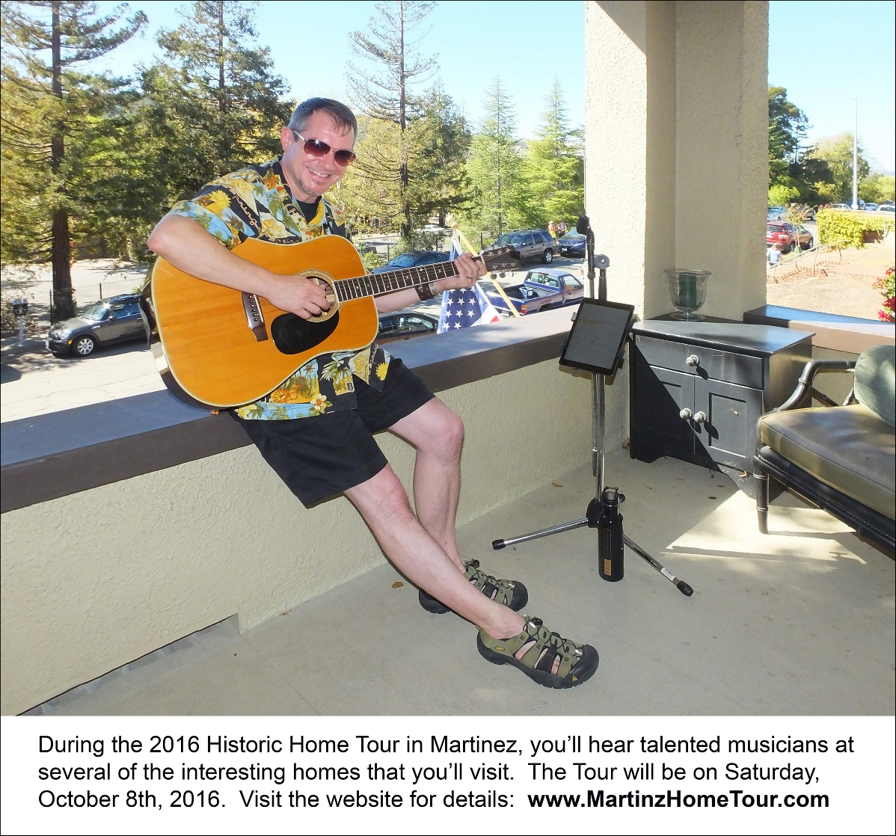
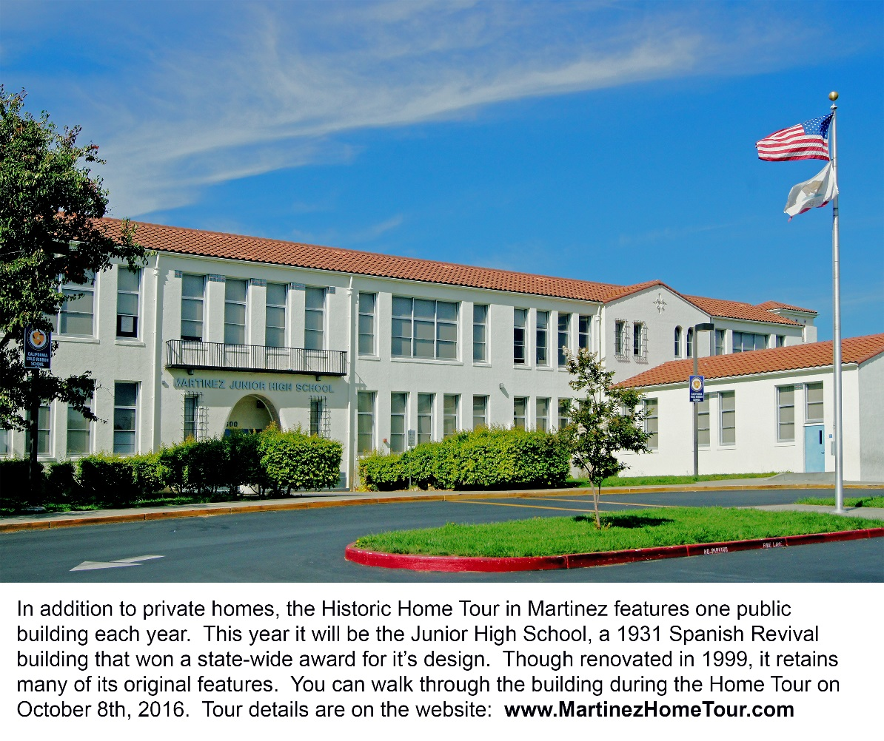

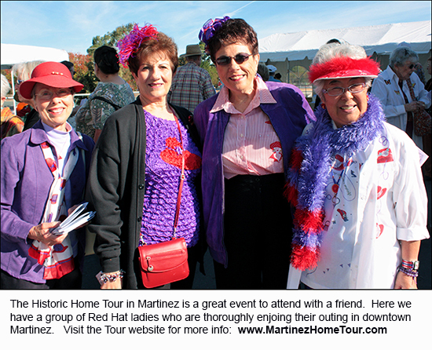

Note to editor:
- To see more Home Tour photos, please click here: press materials

